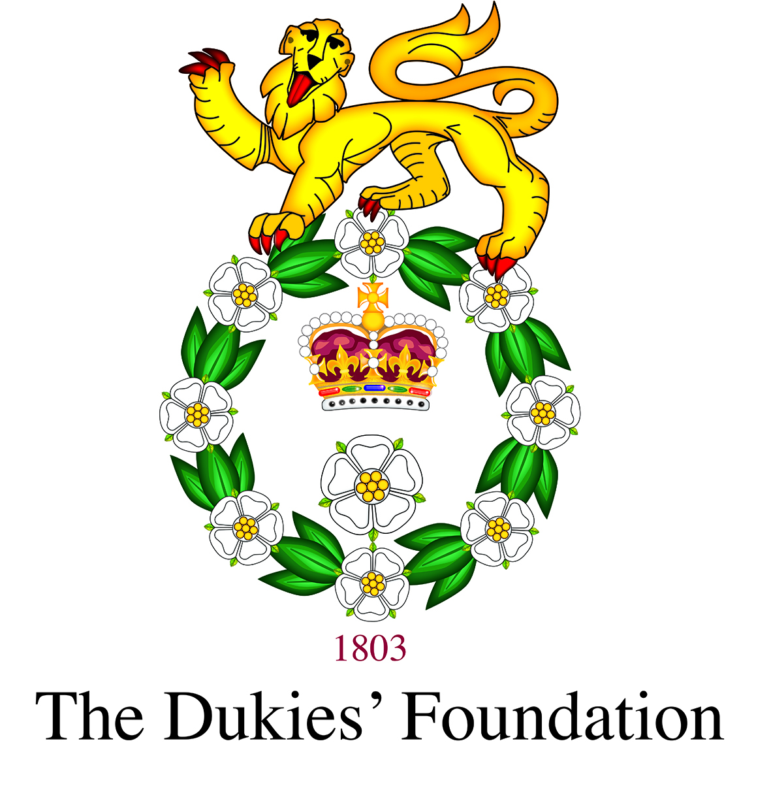 The Dukies’ Foundation - Charity No 1128684
Giving Form

Title ___________________________ First name* ______________________________________________________ Surname* ______________________________________________________________
Full home address* _________________________________________________________________________________________________________________________________________________________
________________________________________________________________________________________________________________________________________________________________________________
Postcode*_________________________________ Email* ______________________________________________________________ Phone number _________________________________________
* Required fields, if you do not own an email address please ensure you complete the phone number section.

I would like to allocate my gift towards:

☐ Student Support | ☐ Leadership Activities | ☐ The DOYRMS’ Greatest Need
☐ Other (please specify): ______________________________________________________________________________________________________________________________________________

Regular Gift
☐ I would like to make a regular gift of: | ☐ I am currently making a regular gift and would like to change the amount to:
☐ £10 ☐ £25 ☐ £50 ☐ £100 ☐ £250 ☐ £500 ☐ £1,000 ☐ Other (please specify amount), £_______________________________________________
Starting on 1st of month: ________________________ year: _________________ Monthly/Quarterly/Annually (please delete as appropriate.)
Please make start date at least one month from today.

Instruction to your Bank or Building Society to pay by Standing Order
Please complete and return to, Alumni & Development Officer, Duke of York’s Royal Military School, Dover, Kent, CT15 5EQ or alumni@doyrms.com
To: The Manager
Bank/Building Society: _____________________________________________________________________________________________________________________________________________

Address: _____________________________________________________________________________________________________________________________________________________________

________________________________________________________________________________________________________________________________________________________________________

Name(s) of account holder(s): _____________________________________________________________________________________________________________________________________
Bank/Building Society Number: |  |  |  |  |  |  |  |  | Sort Code: |  |  | - |  |  | -

Instruction to your Bank or Building Society
Please pay The Dukies’ Foundation via Standing Order from the account detailed in this instruction. I understand that this instruction may remain with The Dukies’ Foundation and, details will be passes to my Bank/Building Society.

Signature(S): _________________________________________________________________________________________________ Date: ___________________________________________________
Reference**: | **Your unique reference for payment is the first letter of your first name and middle name (if applicable), the first three letters of your surname and the last two digits of the year you left school.  For example: Joe Henry Bloggs (1991 – 1998) – Ref: JHBlo98

Single Gift
☐ I wish to make a one-off gift to The Dukies’ Foundation of:
☐ £25 ☐ £50 ☐ £100 ☐ £250 ☐ £500 ☐ £1,000 ☐ Other (please specify amount), £____________________________

☐ I enclose a cheque/Charities Aid Foundation cheque payable to ‘The Dukies’ Foundation’
☐ I will make a BACS Transfer to the following account details

The Dukies’ Foundation Lloyds Bank account number: 01780588 Sort Code: 30-93-34

Legacies
☐ Please send me information about leaving a Legacy to The Dukies’ Foundation | ☐ I am leaving a Legacy to The Dukies’ Foundation

Gift Aid
If you are a UK taxpayer and choose to donate using Gift Aid, we can reclaim 25p for every £1 that you give, at no extra cost to you. To be eligible for Gift Aid, you must be a UK taxpayer and you must not pay less Income/or Capital Gains Tax in a given year than the amount of Gift Aid claimed on all your donations in that tax year. If you pay less than this amount of tax, it is your responsibility to pay any difference. Please notify The Dukies’ Foundation if you change your name/address or no longer pay a sufficient amount of tax.
I wish The Dukies’ Foundation to treat this gift, all donations made 4 years before the date of declaration, and all future donations after the date of declaration until further notice, as Gift Aid.
Signature(S): _________________________________________________________________________________________________ Date: ___________________________________________________

Please complete and return to,
Alumni & Development Officer, Duke of York’s Royal Military School, Dover, Kent, CT15 5EQ or alumni@doyrms.com

We take care of your data: All data is held securely and confidentially. See doyrms.com/Policies for our privacy policy

