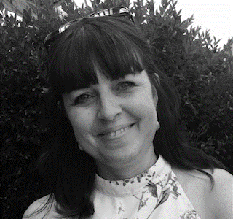
Rachel Robinson
Alumni & Development Officer
My background includes being a boarder at school in Folkestone in the 80s where I was first introduced to the School. I attended Grand Day and Remembrance Weekend then and more recently, having reconnected with many of my friends from school. I understand the importance of being in touch with people who understand the life of a boarder and that of a military family. My father was a boy soldier at Old Park Barracks who progressed through the ranks to Lt. Col in the Royal Engineers, so I have lived the ‘army life’ and the boarding school life, as many of you have. I also have 15 years of experience working in secondary schools.
My role is to organise alumni events, liaise with the The Dukies’ Association (TDA) and The Dukies’ Foundation (TDF), in order to support the building and development of our community.
Our Alumni website, www.dukies.co.uk, is designed to be inclusive to all Dukies, to encourage everyone to join this unique community, to share their stories, photos and news, to reconnect with old friends and possibly make new ones. There will be the opportunity to connect with ‘Dukies in business’, to gain advice, mentoring and possibly even job opportunities - Dukies inspiring Dukies.
I look forward to working with the school and the Alumni and hope to meet you in person at future events.
If you want to know more about TDA, TDF or the website, please email me at alumni@doyrms.com.

